Argha Das
24341220
CSE421 Section13
Spring 26

Get Request
Frame:
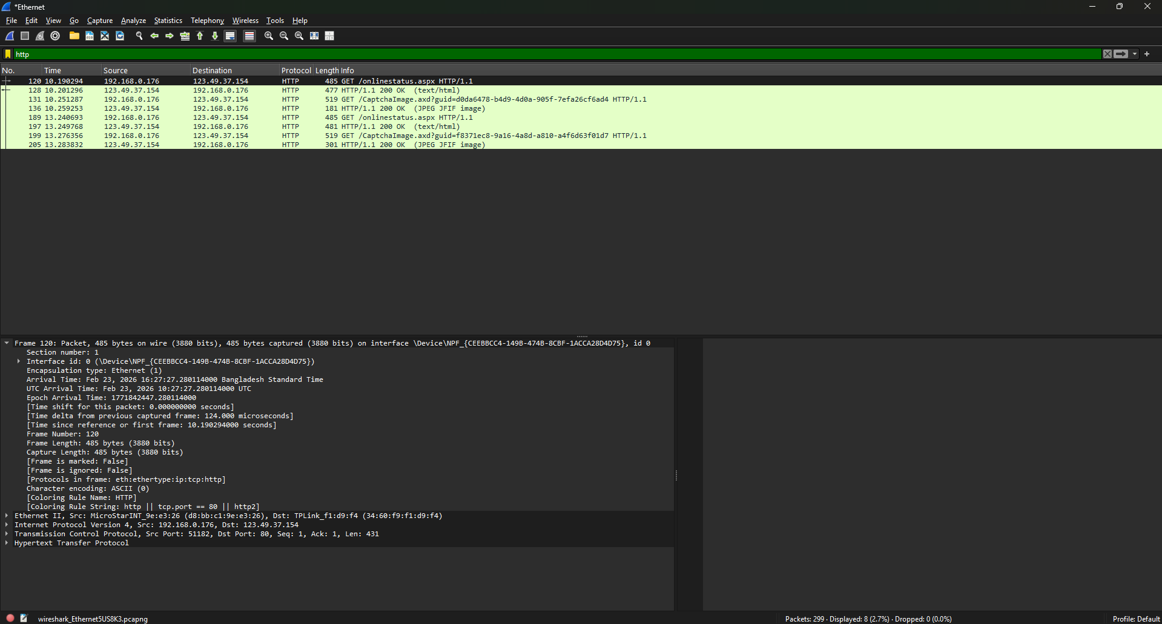
The frame falls under the data link layer. Here, it indicates the frame information of this layer protocol of this capture

Ethernet:

IPv4:
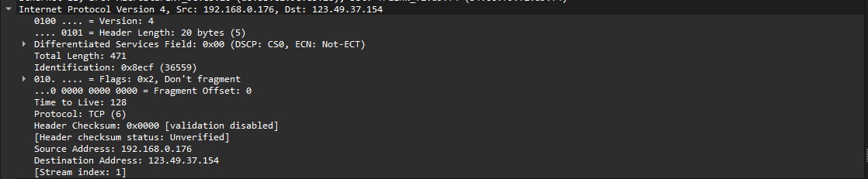

Transmission Control Protocol:
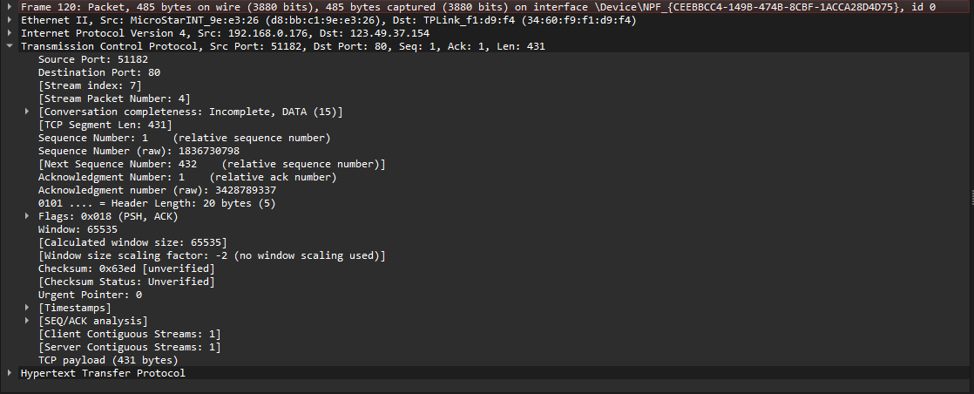
- Source Port: 51182 (ephemeral client port)
- Destination Port: 80 (HTTP service)
- Sequence Number: 1 (relative)
- Acknowledgment Number: 1 (relative)
- TCP Payload Length: 431 bytes
- Flags: PSH, ACK
- Window Size: 65535
The presence of destination port 80 indicates that this packet is part of an HTTP communication. The PSH and ACK flags suggest that data is being pushed to the receiving application and acknowledged.

Http:
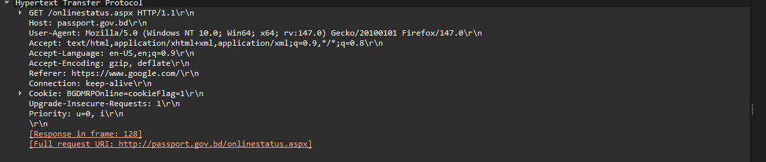
Here, the browser is requesting information from the server, as indicated by the "GET" method. The requested resource is "/onlinestatus.aspx", and "passport.gov.bd" is the server’s address shown in the "Host" field.The "Connection" header requests the connection to remain open for future communication. The system is running Windows 10 and using Firefox, while the "Accept" header shows the types of content the browser can process.

Get Response:
Frame: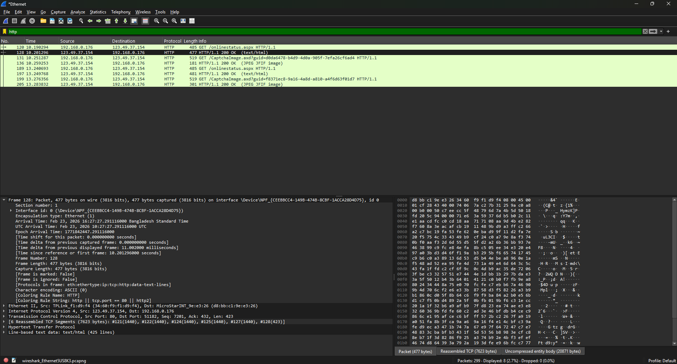

Ethernet:

IPv4: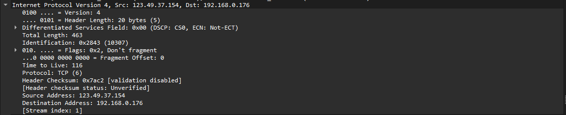This is an IPv4 packet from 123.49.37.154 → 192.168.0.176 using TCP (Protocol 6). Header length is 20 bytes, total packet size is 463 bytes. The Don’t Fragment (DF) flag is set, so the packet cannot be fragmented.TTL is 116, meaning it has passed through several routers before reaching the destination.

Transmission Control Protocol: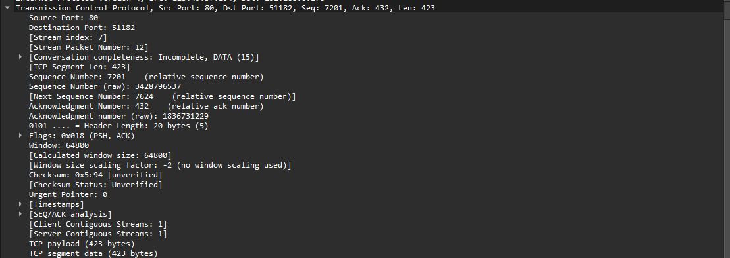This is a TCP segment from Port 80 → 51182, meaning it’s likely an HTTP response from a server. Sequence number is 7201, the acknowledgement number is 432, with 423 bytes of data. Flags PSH, ACK indicate the server is pushing data and acknowledging received data. The window size is 64800, showing how much data it can receive without acknowledgement.

Http: